Hatton (Cruden) School Newsletter

October 2020

Happy holidays…nearly!

Can’t quite believe that we have reached the end of the first term. I hope you find the following information useful and I hope you have a lovely October break when it comes.

We are still receiving calls on our old school number (this comes through to our red emergency phone). Please make sure you are using our new school phone number: 01779 403710 to contact the school. Please also remember to ring before 9.30am on the day of an absence as this helps us to ensure all children are safe and accounted for. We would also ask that you return any forms back to school on time to help with the administration tasks associated with these. Thank you.



**REMINDER DATES:**

**Monday 26th October –** School opens for Term 2

**Friday 20th November–** In-service day

**Thursday 3rd December –** Flu immunisations

**Friday 18th December –** School closes for Christmas holidays

Playground Leak

Due to unforeseen circumstances, the leak in our playground has taken much longer to fix than we had originally thought. There has been an issue sourcing the correct equipment to fix the leak, however I am hopeful that this will be fixed very soon. I would like to take this time to thank you for your patience and apologise for any inconvenience this may have caused.

Christmas Events

Due to the current restrictions we are under, we are unable to provide any details as to the kind of Christmas events we will be able to host next term. However, we will keep you up to date when we return in term 2 and will aim to celebrate in a fun and exciting way, no matter what the restrictions may be at the time.

Hatton School Garden

Our pupils have been working very hard in our school garden and have designed plans for what they would like it to look like. I would like to take this time to thank Ethan Willox and his family for helping the school to clear our garden space and prepare our polytunnel area for planting, it was much appreciated. I can’t wait to see what lovely things we can grow over the coming years.

School Vision Statement Refresh Survey

Around 37% of our parents/carers responded to our School Vision Statement survey. As the new Headteacher at Hatton (Cruden) School, I would like to review how well the school's vision statement and aims reflect our current values and aspirations. The feedback from this survey will help to inform the final 'vision reset' and the 'refreshed' statement will be the backdrop for our school's improvement journey. Here are some of the comments we received in our survey.

* I like the school aims. Could add in something about being 'On TRACK' and respecting the UN Rights of the Child.
* A shorter vision would be good so children can easily learn and understand the school vision too.
* Confidence and kindness to be specifically mentioned in the aims as teamwork, respect and achieving are.
* I would like to see kindness mentioned in the vision.

Pupil Equity Funding (PEF)

In our Return to School survey, we asked what our parents thought were the main priorities for 2020-2021. Overall, we had 26% responses and there were three clear priorities indicated from the returns which were: safety and well-being, targeted approaches to literacy and numeracy, and promoting high quality learning experiences. I will be focussing on these areas as part of my PEF planning and spending for 2020/21. Thank you again for your support.



Sensory Space

I am looking to develop the Hatton Hub provision further and want to have a space in school for children with sensory needs and a place where some children in school can reflect and settle their emotions. If you know of anyone who may have some 2nd hand equipment or that could help source resources, then please get in touch with me. We all agree and value the importance of social and emotional well-being and having a space in school that caters for that would be a great addition to our provision.

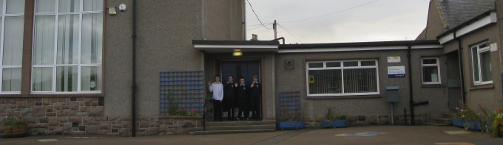

<http://hattoncruden.aberdeenshire.sch.uk/>

@CrudenHatton

<http://hattoncruden.aberdeenshire.sch.uk/>