Hatton (Cruden) School Newsletter

September 2020

**Hello**

It has been a busy yet exciting month having the children back to school. Now that we have settled back into a school routine, we decided to get some feedback from our pupils and parents. Thank you very much to all of you who responded to our questionnaire, it is much appreciated. More information regarding your feedback and our pupil surveys can be found below.

**Absences**

When leaving a message to report an absence please ensure you state the reason for the absence. To help keep our pupils and staff safe, please can you ensure that your child arrives on time for school with everything they need for the day (including snack, water and packed lunch).  We are also encouraging pupils to tie their hair back.

|  |  |
| --- | --- |
|  |  |

**School Office**

For the time being, we are asking all parents to contact the school via telephone or email to limit the number of people coming into our school building. If someone is not in reception to answer your call, the answering machine will pick up your message and will return your call as soon as possible.

The following times are when Miss Steele will be able to answer phone calls.

Monday – Thursday = 08:30 – 15:20

Friday = 08:30 – 12:15

**Adverse Weather**

As we approach the winter months, we need to think about procedures for possible School Closures during adverse weather. Please keep an eye on the Aberdeenshire message service on the website (<https://online.aberdeenshire.gov.uk/Apps/Schools-Closures/>) for updates as your first port of call. We will also send out messages via other communication channels as soon as we can. Safety of staff and children is paramount when making decisions on transport and school closure. Keep an eye on local weather updates as any ice, flooding, snow or storms could have an impact on if and how children and staff get to school.

**IMPORTANT DATES:**



**Reports to Parents**

Friday 23rd September 2020

**Parents Evening Phone calls**

Week beginning 28th September 2020. – More information to follow.

**October Holidays**

12th to 23rd October 2020

**Term 2 begins**

Monday 26th October 2020

**Seesaw**

We have several parents who are not receiving messages from the class as they haven’t signed up to the new Seesaw class accounts yet. If you have lost, misplaced or not received your sign-up code, we can print it and send it again, please let us know.

**Water Bottles**

Please make sure your child has their water bottle cleaned and refreshed with **water** every day to minimise the amount of refilling we will need to do throughout the school day. Staff will not be able to wash/clean out drink bottles at the end of the day. Thank you.

**Reporting**

Due to the current restrictions preventing parents coming into school, this term we are going to hold Parents Evening via telephone call. Your child’s Interim Report will be sent home on Tuesday 22nd September 2020. Along with their report, there will be a letter asking if you would like a phonecall meeting to discuss the report and how your child has settled into their class this term. Phone call meetings will take place on Wednesday 30th September 2020.

**Return to School Survey Results**

Thank you very much for taking the time to complete our Return to School Survey. We had 20 people respond and we are delighted with the positivity shown towards our efforts to support our pupils in their safe return to school. When asked how well the school communicated with parents/ carers in the lead up and first few weeks of being back to school, we received an average of 4.2 out of 5. Here are some of your comments from the survey.

“the school have kept good communication and my child knows what she can and cannot do in term of new guidelines with Covid.”

“I am confident that all is being done to ensure my child’s safety.”

“I would like more communication from teachers of how the kids are doing.”

“No concerns - there is excellent communication and feel my child is safe attending the school.”

“The school have done an amazing job of getting the children settled back into school under these challenging times. I appreciate their hard work very much.”

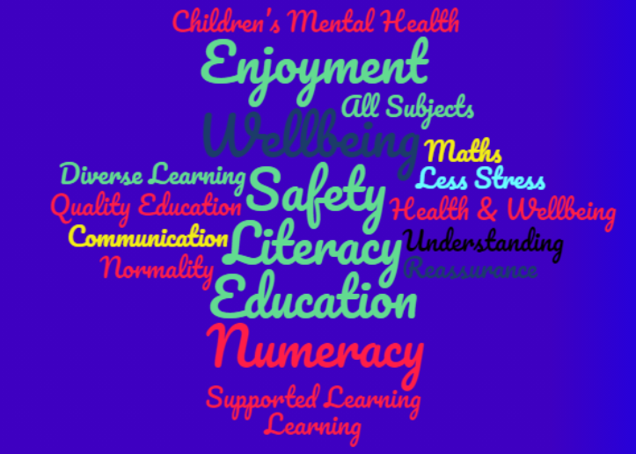“Full school lunches need to be reinstated as a priority as for some families it may be the only hot meal a child receives every day. Issues around ventilation and open windows need to be addressed as we move into autumn/winter months.”

“Yes, they've have spoken about hand washing, the signs for 2metres and the tape on the floor which makes them feel safer.”

To help us with our school improvement plan for the year, we asked the following question.

**What do you believe are the key priorities for our school for 2020/2021?**

I have put the results together into a word cloud and the words which stand out the most are the words which were repeated the most. We will use the results from this survey to help inform our school improvement planning for this year.

**Wellbeing Indictor Survey for Pupils**

Eight words describe what things look like when school life is going well – Safe, Healthy, Achieving, Nurtured, Active, Respected, Responsible, and Included. They are often referred to as our “Indicators of Wellbeing.” Recently, we sent out a questionnaire to all our pupils. We are pleased to announce that over 82% of our pupils identified that we are doing well for every wellbeing indicator at Hatton (Cruden) School, with over 90% of our pupils stating that we give opportunities for pupils to be Responsible and Included. As a result, we are going to incorporate the Wellbeing Indicators into our assemblies and focus on one of the indicators each week, to further develop our understanding and improve the wellbeing of all our pupils at Hatton (Cruden) School.

**Whole School Gardening Project**

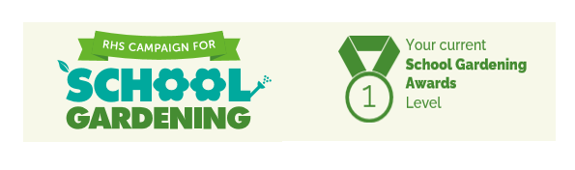A greater focus is being placed on improving the Health & Wellbeing of our pupils, post lockdown, this year. Therefore, we have decided to launch a whole school project to help develop our school playground, and in particular our school garden area. Throughout this project, our pupils will develop vital life skills, such as how to work together and how to grow their own vegetables. I am pleased to announce, that as part of this project, we joined up to the Royal Horticultural Society’s School Campaign and have already earned our first award. This has resulted in the school winning a yearly calendar full of different activities and tips to help develop our school garden. We are looking forward to earning more awards and see our garden flourish throughout the year. If you would like to help with our project, please contact the school via telephone or email.

**Symptoms of COVID**

Please do not send your child and any siblings to school if they or someone in the household has developed symptoms (new persistent cough or increased temperature). Please contact the school to make us aware and use the following link for further guidance on next steps: https://www.nhsinform.scot/campaigns/test-and-protect

We are entering the season where we will see more common colds and illnesses but as a school, we must all support each other to ensure our school remains fully operational as much as possible through these coming months.

**Contingency Plan**

Should we be required to return to full lockdown, we will follow the plan used last term.

Should blended learning be required, where class sizes are reduced, we will return in two groups for two days each week. If you require any further details at this point, please be in touch.

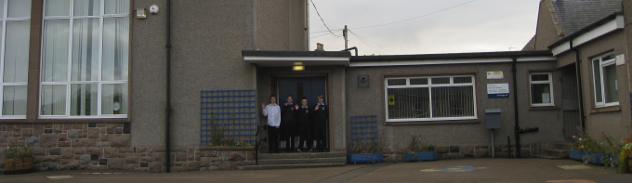

<http://hattoncruden.aberdeenshire.sch.uk/>

@CrudenHatton

<http://hattoncruden.aberdeenshire.sch.uk/>